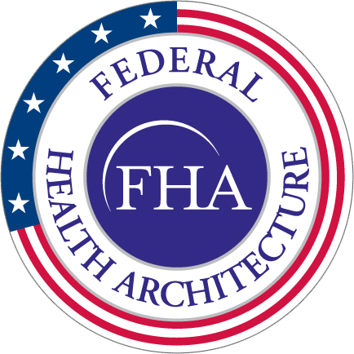**MEETING TITLE Agenda**

FHA Health Information Modeling Work Group (HIM WG)

February 9th, 1-2pm EST

Dial-in: 1-888-537-7715;03956466#

Webinar: <https://attendee.gotowebinar.com/register/8967770038030258177>

**DAY, DATE**

**TIME / Capitol View**

**Minutes**

|  |  |  |
| --- | --- | --- |
| 1:00 – 1:10 | **Welcome and roll call**   * Attendees: Alberto Llanes, Dan Morford, Dave Carlson, David Bass, Gary Dickinson, Hung Trinh, Jay Lyle, Lucy Burge, Mulikat Sarumi, Nancy Orvis, Patricia Greim, Steven Mahalec, Susan Campbell, Galen Mulrooney, Sean Muir, Steve Hufnagel, Steve Wagner, Lindsay Cushing | Steve Wagner |
| 1:10 - 1:20 | **Overview of three FHIM information domains to be distributed to the federal partners for review/feedback**   * Care plans, Medications & Pharmacy, Imaging & Radiology domains have gone through detailed modeling and are complete, with comments. * The team is requesting feedback on terminologies and value sets. It is expected to be put together with all relevant artifacts by the end of this month. * The Care Plan Model is based on the HL7 Domain Analysis Model put together by the Patient Care WG enhanced with SME input. * Galen believes the most useful part of the Care Plan Model is the notion of a Care Team member. The FHIM locks down the people who are characterized as the Care Team, a notion that will be used in different parts of the model. The priorities of the Care Plan may look different from each member of the Care Plan which is why we need people from a variety of backgrounds in the field to look at this and give input. * The Imaging domain combines the imaging and radiology domains. It is aligned with the DICOM set of standards. There was discussion regarding different image formats and content since many kinds of images from a non-clinical setting have become relevant to care plans. * The Pharmacy Model is the same ordering pattern that we see elsewhere. It is broken up into inpatient and outpatient. Many of the classes that pharmacy reuses are based on the HL7 v.3 Common Product Model that is heavily used by the FDA; starts from the product and moves downward into packaging and manufacturer, etc. The model now includes traditional products and locally manufactured products. * Many of these classes having to do with payment and come from NCPDP Telecom and Script standards. * The review materials will include the diagrams as well as the definition of the classes and attributes, value set names, and sometimes the actual value sets. Galen requests that they are widely dispersed to SMEs with fresh eyes. | Galen Mulrooney, Jay Lyle, Sean Muir |
| 1:20 - 1:30 | **Brief on investigative study of the potential to integrate CIMI and FHIM**   * See attached slides for presentation content. | Steve Hufnagel |
| 1:30- 1:55 | **Presentation and discussion work completed to generate FHIR artifacts/standards from MDHT and FHIM**   * See attached slides for presentation content. * Slicing allows you to define and restrict a collection of content. * Question raised regarding interoperability. Sean responded that the tool is designed to promote interoperability. Agencies would not have to create their own FHIR profiles; they can use or modify existing profiles. * Question whether FHIM is exported or represented within the tool. Sean responded that this is strictly extensions to MDHT for FHIR that we would then leverage from the FHIM. Any valid FHIR profile can be incorporated. They are producing FHIR standard structures as an output. * Question regarding NIEM compatibility. They created an IEPD inside the NIEM profile, using the NIEM tooling. Gaps included generating a domain. They are able to constrain existing content within a NIEM domain. Most things were considered extensions under the NIEM approach but are considered NIEM compliant using NIEM structures and guidelines. Use cases include prison inmate health information being exported to a localized provider. * IPO is sponsoring a Joint Exploratory Team to stand up a FHIR Proving Ground at TATRIC and will be holding DoD/VA joint FHIR CONNECT-a-thons. * FHA should encourage the use of MDHT to create the DoD/VA health profile. * HHS may be in the process of sponsoring a FHIR CONNECT-a-thon as well. | Sean Muir and Galen Mulrooney |
| 1:55 – 2:00 | **Wrap-up, and action items** | Lindsay Cushing |
|  |  |  |